SEAA Hong Kong Conference 2016: Useful Information
19–22 June 2016

1. Travel tips

Travel from airport to CUHK

Taking the taxi
One simple and fast but somewhat expensive way to get to CUHK is to take a taxi from the airport. Take a green-colored cab, not a red-colored one: those are cheaper. The ride to CUHK campus should cost you HK$350 or so. Be sure to use the addresses in Chinese given below, to advise the driver where you want to go

Conference venue (Mong Man Wai Building, CUHK):
沙田香港中文大學 蒙民偉樓

CUHK Guesthouse:
沙田香港中文大學 昆棟樓大學賓館

CUHK Student dormitory (at New Asia College):
沙田香港中文大學 新亞書院學生宿舍

(For venues above, the driver should stop at the main gate of CUHK to confer with the guard as to the exact location of your destination.)

Hyatt Regency Hong Kong, Sha Tin:
沙田凱悅酒店 (酒店鄰近大學火車站)

Chunking Mansions, Tsim Sha Tsui
尖沙咀彌敦道重慶大廈

Taking the MTR

You can take the MTR at the airport (i.e. Airport Station) and travel to the University Station. This costs HKD60 and takes about 65 minutes. If you are going to the Hyatt Regency, exit at Exit B and the hotel is located among the buildings on your right-hand side (which takes about 3 minutes to walk there). Exit at Exit A or C to take the in-campus transportation (see the information in the next session) to get to the conference venue/guesthouse/student dormitory.

(MTR system map: http://www.mtr.com.hk/archive/en/services/routemap.pdf)

(Station map of University station: http://www.mtr.com.hk/archive/en/services/maps/uni.pdf)

Taking the airport bus and the taxi/train

Take airport bus route number A41 from the airport to the Shatin Central Bus Terminus (the stop after Lantau Link Toll Plaza, i.e. the 3rd stop of the bus route). The fare is HK$22.3 payable on boarding in cash (exact fare only, no change given) or by Octopus Card. The bus runs from 06:00 to 24:00 at 20-minute intervals. The bus ride takes 40–50 minutes to the Shatin Central Bus Terminus, depending on traffic conditions. The Shatin Central Bus Terminus is not the terminal stop for the bus, so please pay attention to the announcement, or ask the driver where to get off.
(More about the bus route: http://www.kmb.hk/en/services/search.html)
Connected by:
• Taxi (red): From the Shatin Central Bus Terminus, you can take a taxi to CUHK. The fare is about HK$50. It takes about 15 minutes. Most taxi drivers in Hong Kong understand some English and Putonghua. Taxis only accept cash payment.
• MTR Train (Not recommended if you have bulky luggage): Alternatively, you can walk to Shatin MTR Station which is located near the Bus Terminus. Take a train to the University MTR Station. The fare is about HK$4.5 which is payable by single ticket or Octopus Card.

Octopus Card Service

If you want to be more adventurous in Hong Kong, it is recommended that you buy an Octopus Card for your own convenience. It can be used in most of the transportation, including buses (this includes A41), MTR, ferry, and some of the minibuses; it can also be used in most of the vending machines, convenient stores, and fast food shops. Octopus cards can be bought at the Customer Service Centres in the Airport Express Line and in all MTR stations (except Racecourse station). Ticket price for adults is HK$150 (with HK$50 of deposit which is refundable, and HK$100 of stored value). Some modes of transport give a slight discount to Octopus card users and having the card prevents you from worrying about always needing exact change. It is very easy to use: simply swipe your card over the octopus machine, the fare will be automatically deducted, and its deducted values and remaining value will be shown on the screen of the machine.

(More about Octopus Card: http://www.octopus.com.hk/get-your-octopus/choose-your-octopus/on-loan-octopus/standard-octopus/en/index.html)

Downtown Restaurants

There are more restaurants in Hong Kong per square foot than anywhere else on earth, so a guide is not so necessary. But just a few words may be useful. The closest shopping mall to CUHK is the New Town Plaza, in Shatin, where an array of restaurants of various types and nationalities, a department store (YATA), and various shops can be found in Tsim Sha Tsui, Ashley Road is a good restaurant street, with 15 or so different places, from Chinese to Japanese to Korean to Southeast Asian to Italian. For adventurous types, Chungking Mansions, 36-44 Nathan Road, beckons: you will be mobbed by touts as you approach, and just follow any one of them for a good cheap Indian meal.

(Dining directory of the New Town Plaza: http://www.newtownplaza.com.hk/dining_directory)

Explore Hong Kong

The website “Discover Hong Kong”, launched by the Hong Kong Tourism Board, provides comprehensive introduction to various attractions and happenings in the town.

(Discover Hong Kong: http://www.discoverhongkong.com/eng/index.jsp)

If you are a museum lover, you may also take a look at the directory of Hong Kong public museums. These museums may close on different weekdays, and some may have renovation projects taking place, so you are advised to check the information online before visiting.

(Directory of Hong Kong public museums: http://www.museums.gov.hk/en_US/web/portal/about-us.html)

Ocean Park and Disneyland are the two large theme parks in Hong Kong with various attractions and rides. Ocean Park is a marine-life theme park featuring animal exhibits and shows, while Disneyland has musical performances and fireworks show.

(Ocean Park Hong Kong: http://www.oceanpark.com.hk/en)

(Hong Kong Disneyland: https://www.hongkongdisneyland.com/)

Traveling to Macau takes around an hour by ferry from Hong Kong. The Historic Centre of Macau has been listed as a World Heritage site by UNESCO. Macau also has a unique blend of Portuguese and Chinese cultures.

(Going to Macau: http://www.discoverhongkong.com/eng/plan-your-trip/traveller-info/transport/getting-here/by-ferry.jsp)

Weather

Hong Kong has a subtropical climate with temperatures ranging from 26˚C to 33˚C in June. Please also bring an umbrella with you, as it also rains a lot in Hong Kong. For weather forecast, please visit the website of Hong Kong Observatory: http://www.hko.gov.hk/contente.htm.

2. Campus information

Campus Transportation and Map

CUHK is relatively large, and the university provides shuttle bus services taking people to different parts of the campus. The closest MTR exits to the shuttle bus stops are Exit A (Route No.2) and Exit C (Route No.H, No.1A, No.1B, and No.N). Each route has its own schedule, for details, please refer to the “Shuttle bus schedule” on P.8.

Transportation to the conference venue

[Route No.H (on 19 June), Route No.1A and No.1B (on weekdays and Saturdays)]

To go to the conference venue, you can take No.H, No.1A and No.1B shuttle bus. Get off the bus at the stop as instructed in the maps below, cross the road to the “Sir Run Run Shaw Hall”, turn right and walk down to the Mong Man Wai Building, which can be recognized by its distinct yellow paint.

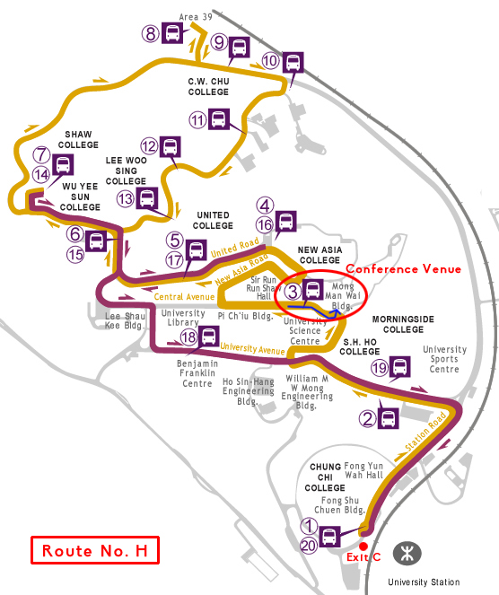
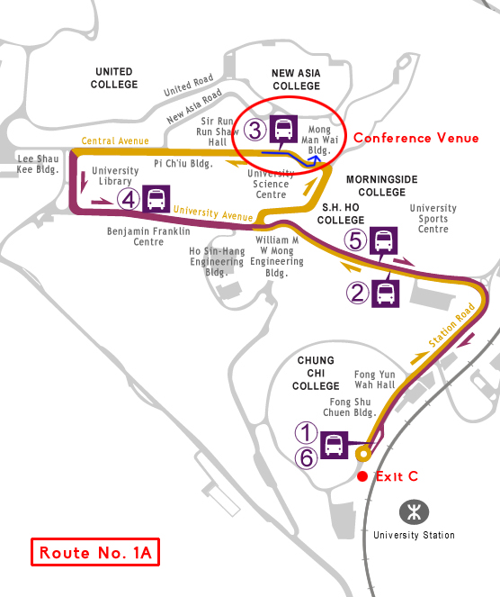
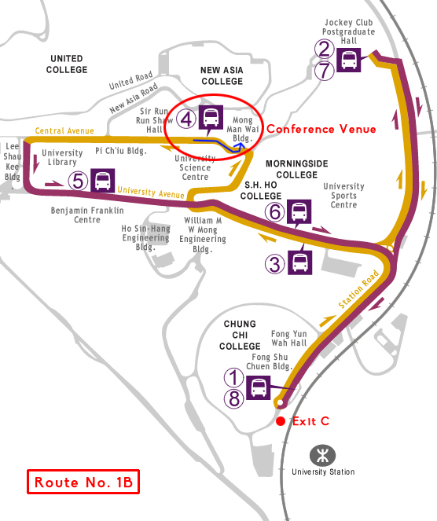
Going to the Guesthouse

Transportation to the Guesthouse is same as that to the conference venue, you need to get off the bus at the same stop and walk down to the Mong Man Wai Building. It takes a five-minute walk from the Mong Man Wai building (G/F) to the Guesthouse. You can go down to the Guesthouse from the building by nearby stairs (the blue route), or walk down the slope (the red route).

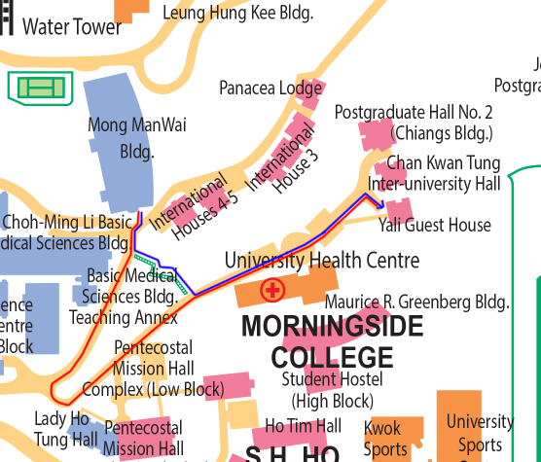

Transportation to the student dormitory

The student dormitory is also close to the Mong Man Wai Building. It takes a five-minute walk from the building (7/F) to the dormitories, check carefully which dormitory you have been assigned to: for Grace Tien Hall and Daisy Lee Hall, you need to go downslope (the blue route), and for Xuesi Hall and Chih Hsing Hall, you need to go upslope (the red route).

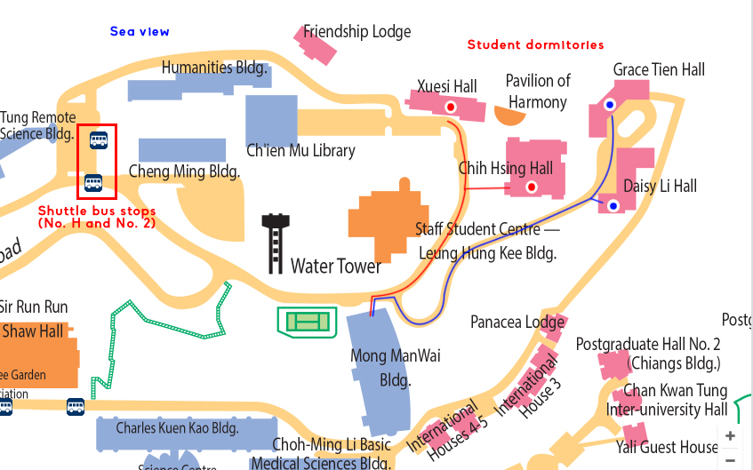
[Route No.H (on 19 June), Route No.2 (on weekdays and Saturdays)]

To go to the student dormitory, you can take No.H and No.2 shuttle bus. Get off the bus at the stop as instructed in the maps below, walk along the road that gives you a sight of the sea view, and you will eventually see the student dormitories.

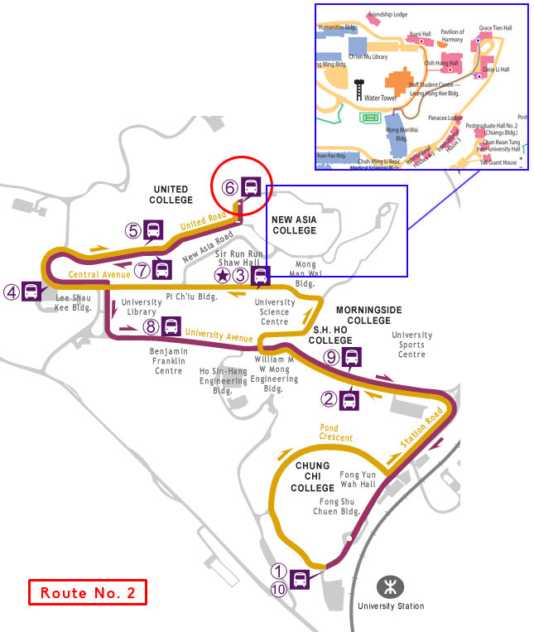
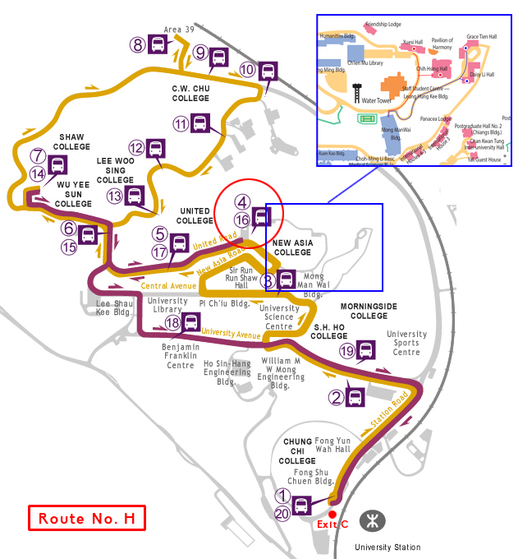

Shuttle bus schedule

(Provide service on Sundays and Public Holidays)
Route No.H: Period of Operation 8:20 am–11:20 pm, departure at every 00, 20, 40

(Provide service on Mondays to Saturdays)
Route No.1A: Period of operation 7:40 am–6:40 pm, departure at every 20, 40
Route No.1B: Period of operation 8:00 am–6:00 pm, departure at every 00
Route No.2: Period of operation 7:45 am–6:45 pm, departure at every 00, 15, 30, 45
Route No.N: Period of operation 7:00 pm–11:30 pm, departure at every 00, 15, 30, 45

Route No.N provides service at night on weekdays. Participants who stay at the CUHK may need to take this shuttle to get back to the Guesthouse / student dormitories. Below is the bus route map for your information. (Please note that the shuttle bus that departs from the University MTR Station at every 00 will call at the Jockey Club Postgraduate Hall.

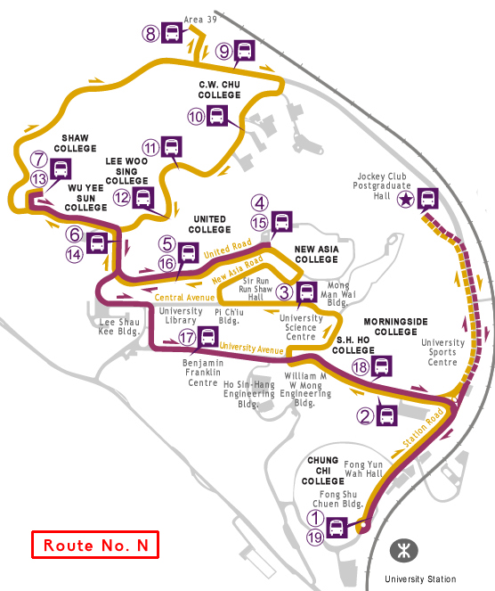

Meals

Canteens near to the conference site and campus accommodation venues include the Medical School Canteen, the New Asia College Canteen, the Morningside College Canteen, and the S.H. Ho College Canteen (for exact locations, please refer to the map in the next page.)

Opening hours of the canteens:
Medical School Canteen: 7:45 am–6:00 pm (Mon–Sat)
New Asia College Canteen: 8:00 am–9:00 pm (Mon–Sat), 11:00 am–9:00 pm (Sun)
Morningside College Canteen: 11:00 am–8:00 pm (Mon–Fri)
S.H. Ho College Canteen: 7:30 am–8:00 pm (Mon–Sun)

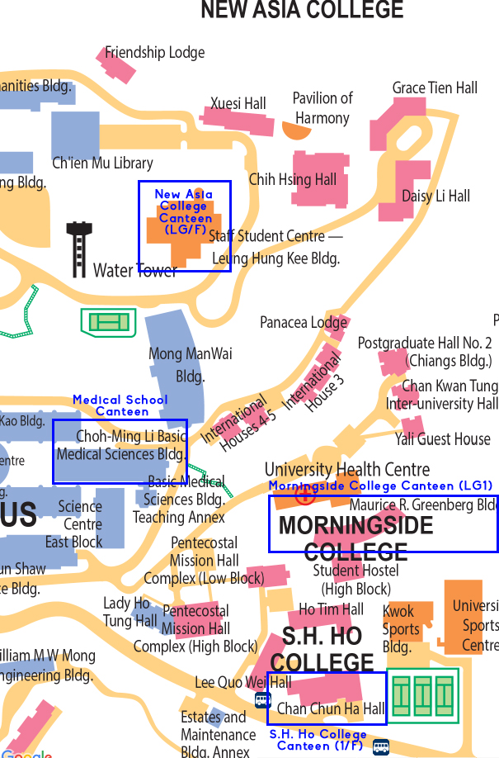
Supermarket and Book Store

Park’n Shop (Supermarket)
Opening hours: 8:30 am – 10:00 pm (Mon – Fri), 8:30 am–9:00 pm (Sat and Sun)
Location: LG, John Fulton Centre

The Commercial Press (Bookstore):
Opening hours: 10:00 am–8:00 pm (Mon–Fri), 10:00 am–6:00 pm (Sat)
Location: 1/F, Yasumoto International Academic Park (close to Exit D of the University MTR Station)

(Campus Map: http://www.cuhk.edu.hk/english/campus/cuhk-campus-map.html)

Contacts

If you have any questions or difficulties, feel free to call the staff of the CUHK Anthropology Department:

Kathy Wong: (852) 3943 7679

Esther Chok: (852) 3943 9264

Grace Tsang: (852) 3943 7670

Irene Chan: (852) 3943 7677

